* Purpose of website & list of features implemented

The website is to provide the blogging service and Bootstrap and jQuery have been implemented to have an intuitive design.

* Analysis

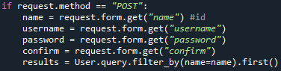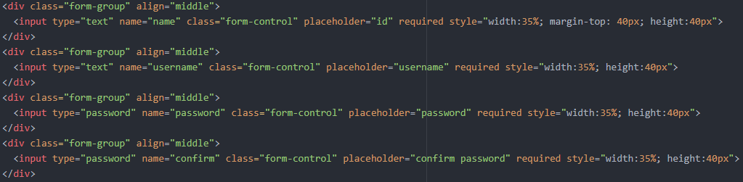Since the application is about blogging and it requires users to have their own account, there must be the security issue in user account if they have set their password less than 8 length, or if password consists of only number. Also, to prevent the record duplicate, such as id, the web application needs to examine that the data from client side is valid.



When user gives input values to server, server will receive these values and check if the id user has typed is already being used. If someone is already using it, it will pop up the message saying id has overlapped with someone’s id.

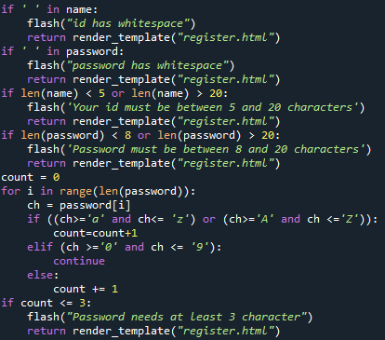

After checking no one is using it, password and id will be reviewed to see if there is a whitespace, if the length of these is too short, or too long, and if there are less than 3 characters, including special letters, in password.

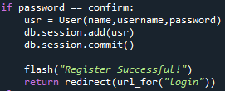

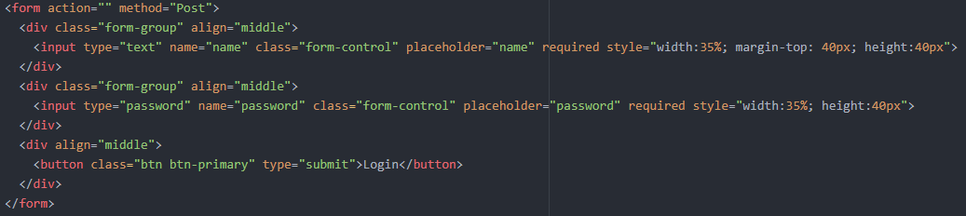Lastly, the application prompts user to type their password twice to reduce typing error, as password is invisible to user when typing.

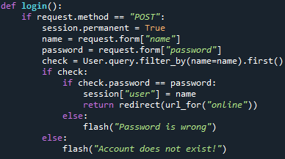

When it comes to login, the application will search the database based on input values and confirm if there is a same id as input value.

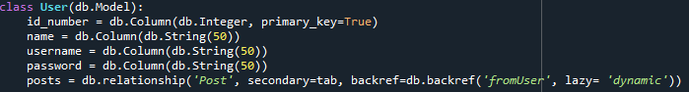

The web application has two classes: User and Post. User class has three columns: id, username, password. The class is declared to store user’s information so that user can use the web application with their id and password.

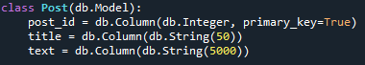

Post class is to store what users have posted, so it has two columns: title and text.

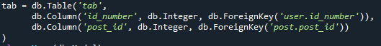

To connect two classes to distinguish each data because users are supposed to see what they have posted in their blog, the many to many relationships is established by adding an association table between two class. Many to many relationships is needed in this web application to verify which post is written from. Thus, many to many relationships lead every data to have their own link to connect other data from another class.

The session is used when user is on online and he explores the application. Web application receives an input value from user when user tries to login and the session will save that data temporarily until user ends up exploring their blog.

When user requests posting or viewing their blog, the application will check the data in session and it will redirect user to login page if there is no data in session, but it is not likely to happen.

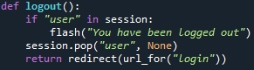Finally, session will release the data when user requests a logout.